**ACKNOWLEDGEMENT**

At most, I thank the Almighty for showering her blessings upon me. This research would not have been possible without her grace.

I would like to express my deep regards to Dr. Hemlata Bagla, Principal of K. C. College for providing me with the facilities of the institution. I would also thank our Vice Principal Dr. Shalini R. Sinha, Co-ordinator of the Department of Computer Science for being a constant source of inspiration and making all the necessary facilities available to me during my project formation.

With immense gratitude, I would like to give a very special honor and respect to my mentor Mrs.Vimala Rani R. who took keen interest in checking the minute details of the project work and guided us throughout the same. Her continuous support, patience, motivation, enthusiasm not only helped in making my efforts fruitful but also transformed the whole process of learning and implementation into an enjoyable experience. I am also pleased to thank other project guides and teachers, Mrs. Geeta Brijwani, Mrs. Shalini Maheshgauri, Mr. Narendra Maurya and Mr. Maunash Jani.

I am thankful to all the non-teaching staff of the computer science department for being so accommodating and co-operative all through. Last but not the least, I wish to avail myself of this opportunity to express my gratitude to my friends for their constant encouragement, support and for assisting me with their inputs. A special thanks to Shreyash Ghag, Hina Chauhan and Swapnil Sawant for helping me throughout the project development**.**

**INDEX**

|  |  |
| --- | --- |
| **Topic** | **Page Number** |
| **I. Preliminary Investigation** |  |
| 1. Organizational Overview |  |
| 1. Description of the System |  |
| 1. Limitations of the present system |  |
| 1. Proposed system and its advantages |  |
| 1. Technologies used |  |
| 1. Gantt Chart |  |
| **II. System Analysis** |  |
|  |  |
| 1. Event Table |  |
| 1. Use Case Diagram, Scenarios and Use case description |  |
| 1. ERD |  |
| 1. Activity Diagram- |  |
| 1. Class Diagram |  |
| 1. Object Diagram |  |
| 1. Sequence Diagram / Collaboration Diagram |  |
| 1. State Diagram |  |
|  |  |
|  |  |
|  |  |
|  |  |
| **Topic** | **Page Number** |
| **III. System Design** |  |
| 1. Converting ERD to Tables |  |
| 1. Design Class Diagram |  |
| 1. Component Diagram |  |
| 1. Package Diagram |  |
| 1. Deployment Diagram |  |
| **IV. System Coding** |  |
| 1. Menu Tree / Sitemap |  |
| 1. List of tables with attributes and constraints |  |
| 1. Design patterns used |  |
| 1. Program Description with Naming Conventions |  |
| 1. Validations |  |
| 1. Test Cases, Test Data and Test Results |  |
| 1. Screen Layouts and Report Layouts |  |
| 1. Program Listing |  |
| **V. System Implementation and Uploading** |  |
| **VI. Future Enhancements** |  |
| **VII. Reference and Bibliography** |  |

**PRELIMINARY INVESTIGATION**

**Organizational Overview**

The website on Food Recipe is the initiative to promote various cuisines of Indian and international among friends and family. Mr. Basant B Rajali is passionate to share his cooking experience with others and involved himself in this field since 1976.

A recipe is a set of instructions that describes how to prepare or make something, especially a culinary [dish](https://en.wikipedia.org/wiki/Dish_(food)). It is also used in medicine or in information technology. A doctor will usually begin a [prescription](https://en.wikipedia.org/wiki/Medical_prescription) with recipe, Latin for take, usually abbreviated to Rx or an equivalent symbol.

Cooking or cookery is the [art](https://en.wikipedia.org/wiki/Art), [technology](https://en.wikipedia.org/wiki/Technology), [science](https://en.wikipedia.org/wiki/Science) and [craft](https://en.wikipedia.org/wiki/Craft) of preparing [food](https://en.wikipedia.org/wiki/Food) for consumption with or without the use of fire or heat. Cooking techniques and ingredients vary widely across the [world](https://en.wikipedia.org/wiki/Earth), from grilling food over an open fire to using [electric stoves](https://en.wikipedia.org/wiki/Electric_stove), to baking in various types of [ovens](https://en.wikipedia.org/wiki/Oven), reflecting unique environmental, economic, and cultural traditions and trends. The ways or types of cooking also depend on the skill and type of training an individual cook has.

Cooking is done both by people in their own dwellings and by professional cooks and chefs in restaurants and other food establishments. Cooking can also occur through chemical reactions without the presence of heat, such as in [ceviche](https://en.wikipedia.org/wiki/Ceviche), a traditional [South American](https://en.wikipedia.org/wiki/South_American) dish where [fish](https://en.wikipedia.org/wiki/Fish) is cooked with the acids in [lemon](https://en.wikipedia.org/wiki/Lemon) or lime juice.

This website promotes cooking and books about recipes by showcasing various cuisines and cooking methods.

**Description of current System**

The work is done manually currently. It does not have any online website. All the records are stored manually in a register. Since lot of work is loaded on single person that single person finds no proper way of having a secured informative, persistent data of anyone who visits home directly or indirectly.

**Limitations of present system**

The present system doesn’t have any online system to store the records of the members. Member are not being kept updated about changes in any information about food items, new food item and new chances in the recipe. Feedback system is not available. Improvements of system is based on feedback. Currently organization have no online trading. Unable to reach out of people.

-

**Proposed system and its Advantages**

* The objective of this project is to help the website to publicize the existence through the electronic media and keep the records of the queries made, which will help the organizations to understand them much and improves.
* To reduce the limitations, a web site for better convenience and ease
* Visitor can just browse through various pages such as Home page, about page, and contact page. Member can browse the site, can order recipe book and make a query which he will get a response back.
* The level of accuracy of this proposed system will be higher. It ensures that whatever information is there in the database is accurate.
* Nowadays people are much more into food as we can call them “Foodies”. The working system has made people busy and have no time to access it. The website enables people learn them easily.
* One can view the information and Home page of the website which contains each information.
* It also ensures that in case if they find difficulty somehow, they can contact to the admin and make a query. Admin makes sure that he response to the query as soon as possible and member gets the respond.

**Feasibility Study**

The feasibility study is preliminary study which investigate the information requirements of perspective user and determine the resource requirements. It accomplishes all the feasibility requirements to develop a good software.

**Economic Feasibility**

* It does not have much development cost, because it is a small-scale project.
* The admin doesn’t require a license to use the website and so it is economical.
* Being an individually developed project it has no expense or salary to employees.
* Since it is a website, it doesn’t require any staff to operate on it. Any updating can be made by the admin and so it doesn’t have salary problem.

**Technological Feasibility**

* Begin a small-scale project, the working of is quite simple.
* The website is user-friendly and so this new technology will save a lot of time of both admin and member.
* The flow of the system is not complicated.

**Organizational and Cultural Feasibility**

* Since the organization didn’t have a website earlier, and the working of the website is easy, there won’t be any confusion as 0 work with the website.
* As the use of computer in today’s world is very common, there is no fear of computer phobia.

**Resource Feasibility**

* Begin an individual developed project it does not require resources like staff or employees.
* It does not have the risk of employees being transferred or staff’s quitting the job.

**Stakeholders**

**Visitors**

* Visitor can access the game and play the game

**Members**

* Member can login.
* Member can access the website and view different pages like Home page, recipe page, about page, contact page, Registration/Login and books page.
* Member can query about the food item.
* Member is the person who can login on website, can order recipe books, ask query and give feedback.

**Administrator**

* Admin can login
* Admin can add, delete and update recipes with images.
* Admin can response to query.
* Admin can add, delete and update recipe books with images.

**Technologies Used**

**GANTT CHART 2017-2018**

**Unity 3D**

**Visual Studio**

|  |  |  |
| --- | --- | --- |
| **Topic** | **Proposed Dates** | **Actual Dates** |
| **I. Preliminary Investigation** | **24th Nov 2017** |  |
| (i) Organizational Overview | **24th Nov 2017** |  |
| (ii) Description of System | **24th Nov 2017** |  |
| (iii) Limitations of present system | **24th Nov 2017** |  |
| (iv) Proposed system and its Advantages | **24th Nov 2017** |  |
| (v) Feasibility Study | **24th Nov 2017** |  |
| (vi) Stakeholders | **24th Nov 2017** |  |
| (vi) Gantt Chart |  |  |
|  |  |  |
| **II. System Analysis** | **15th Dec 2017** |  |
| (i) Fact Finding Techniques | **8th Dec 2017** |  |
| (ii) Event Table | **8th Dec 2017** |  |
| (iii) Use Case Diagram, Scenarios &  Use Case Description | **12th Dec 2017** |  |
| (iv) ERD | **12th Dec 2017** |  |
| (v) Activity Diagram | **14th Dec 2017** |  |
| (vi) Class Diagram | **8th Dec 2017** |  |
| (vii) Object Diagram | **15th Dec 2017** |  |
| (viii) Sequence Diagram | **15th Dec 2017** |  |
| (ix) State Diagram | **15th Dec 2017** |  |
|  |  |  |
|  |  |  |
|  |  |  |
|  | | |
| **Topic** | **Proposed Dates** | **Actual Dates** |
| **III. System Design** | 22nd Dec 2017 |  |
| (i) Converting ERD to Tables | 22nd Dec 2017 |  |
| (ii) Design Class Diagram | 22nd Dec 2017 |  |
| (iii) Component Diagram | 22nd Dec 2017 |  |
| (iv) Package Diagram | 22nd Dec 2017 |  |
| (v)Deployment Diagram | 22nd Dec 2017 |  |
|  |  |  |
| **IV. System Coding** | 23rd Jan 2018 |  |
| (i) Menu Tree / Sitemap | 23rd Jan 2018 |  |
| (ii) List of tables with attributes and constraints | 23rd Jan 2018 |  |
| (iii) Program Description with Naming Conventions | 23rd Jan 2018 |  |
| (iv) Validations | 23rd Jan 2018 |  |
| (v) Test Cases, Test Data and Test Results | 23rd Jan 2018 |  |
| (vi) Screen Layouts & Report Layouts | 23rd Jan 2018 |  |
| (vii) Program Listing | 23rd Jan 2018 |  |
|  |  |  |
| **V. System Implementation / Uploading** | **25th Jan 2018** |  |
| **VI. Future Enhancements** |  |  |

**SYSTEM** **ANALYSIS**

**Fact Finding Techniques**

**Questionnaire**

1. How visitor do’s come across your website?
2. Do you have any advertisement?
3. Do you have any feedback system for improvement of your website?
4. What type of food recipes do you keep?
5. Did they have access to such information easily?

**Observation**

**Event List**

**Visitor**

* Visitor Browses through different Recipes and Books, about us, Contact us , etc.
* Visitor checks the Recipe.
* Visitor registers as a Member.

**Member**

* Member Logs-in.-
* Member Can Post/Upload Recipe.
* Member adds product to the cart.
* Member removes product from the cart.
* Member reviews a product.
* Member browses through Recipe Category and Books, about us, Contact us.
* Member deletes the product from the cart.
* Member enquires about the products to admin.
* Member orders product.
* Member gives feedback.
* Member Can Respond to Comment.
* Member can orders.
* Member can cancel orders.

**Admin**

Admin Login.

Admin Can Upload/Edit/Remove Recipes.

Admin Can Respond to Comment.

Admin Can Check the Registrations.

Admin Can Check Feedbacks.

Admin Can Add New Recipe Books.

Admin Can Check Orders Details.

**Event Table**

|  |  |  |  |  |  |  |
| --- | --- | --- | --- | --- | --- | --- |
| **Sr. No.** | **Event** | **Trigger** | **Source** | **Activity** | **Response** | **Destination** |
| **1** | Visitor Browse through homepage (recipe/about us/ contact us) | Click on home, recipe, contact, registration/ login | Visitor | Loads The home, recipe, contact, registration/login | home, recipe, contact, registration/ login displayed | Visitor |
| **2** | Visitor wants to register | Create New Registration | Visitor | New Registration page | Registration Confirmation  Registration Details | Visitor  Admin |
| **3** | Visitor Search Recipe-- | Search Recipe | Visitor | Search the Recipe | Loads the Recipe Page | Visitor |
| **4** | Member browse through the website | Enter URL | Member | Load the homepage | Homepage displayed | Member |
| **5** | Member login | New login | Member | Record and Verify log-in details | Log-in successful | Member |
| **6** | Member upload recipe details | New recipe upload | Member | Record new recipe details | Recipe details  uploaded | Member/ Admin |
| **7** | Member gives feedback | New feedback | Member | Record feedback details | feedback details | Member/ Admin |
| **8** | Member places an order | New order | Member | Create new order | Order confirmation details | Member/  Admin |
| **9** | Member cancels an order | Cancel order | member | Cancel order | Order cancel details | Member/  Admin |
| **10** | Admin log-in | Login form | Admin | Record login details | Login successful | Admin |
| **11** | Admin upload recipe details | New recipe upload | Admin | Record new recipe details | Recipe details  uploaded | Admin |
| **12** | Admin update recipe | Update recipe details-- | Admin | Update recipe | Recipe  updated | Admin |
| **13** | Admin remove recipe details | Remove recipe details | Admin | Remove recipe | Recipe  removed | Admin |
| **14** | Admin upload new book details | Create new book | Admin | New book details | Book details  updated | Admin |
| **15** | Admin remove books details | Remove books details | Admin | Remove books | Book details  removed | Admin |
| **16** | Admin check feedback details | Lookup feedback details | Admin | Feedback page | feedback details | Admin/ member |
| **17** | Admin views member details | Lookup member details | Admin | Load Member details | Member details viewed | Admin |
| **18** | Admin views comment on recipe | Look up Comments | Admin | Load comment details | Comment details | Admin |
| **19** | Admin updates order | Update order details | Admin | Load Order details | Order details loaded | Admin |

**Use Case-Diagram**

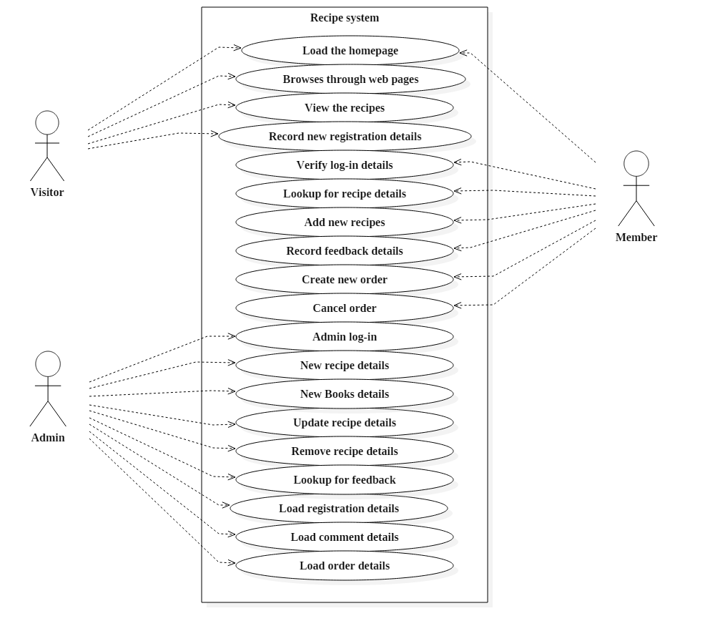

**Use-Case Scenario/Description**

The basic scenario to be considered is as follows:

* Visitor visits Site.
* Visitor Checks Recipe Page.
* Visitor records registration details.
* Member browses through the webpages.
* Member records the login details.
* Member orders for the Recipe books.
* Member records the feedback.
* Admin records the login details.
* Admin records the feedback and order details.
* Admin update the recipe book and offers details.
* Admin views the registered members.
* Admin views the order for the recipe books.
* Admin views the feedback.

**Entity Relationship Diagram (ERD)**

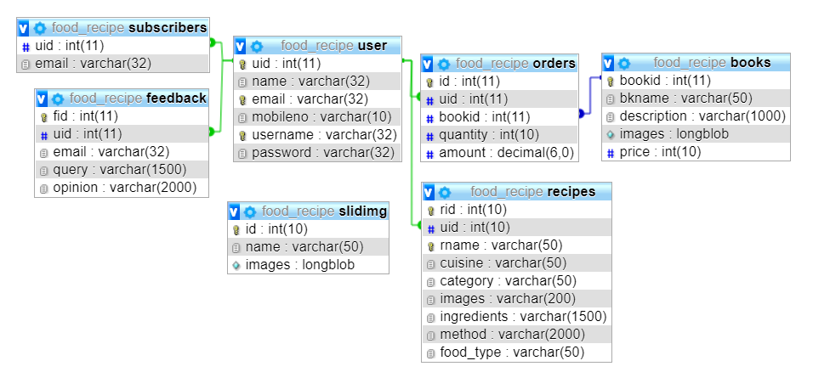

**Activity Diagram**

**Admin**

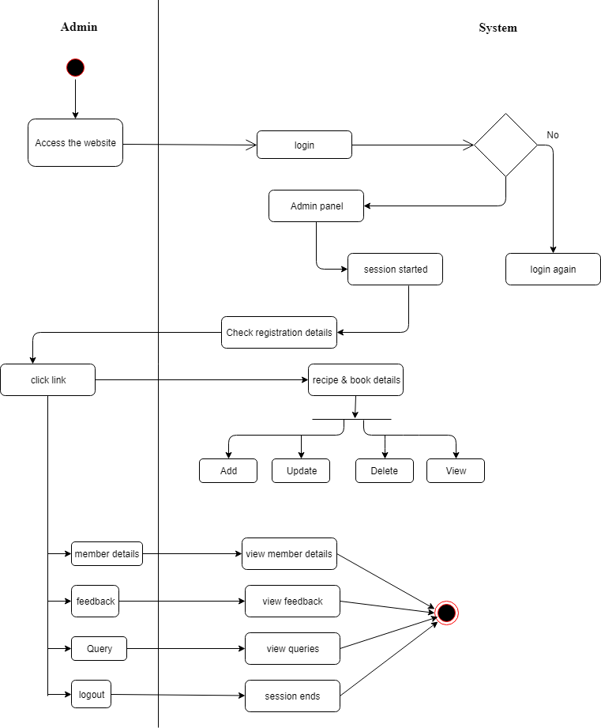

**Member:**

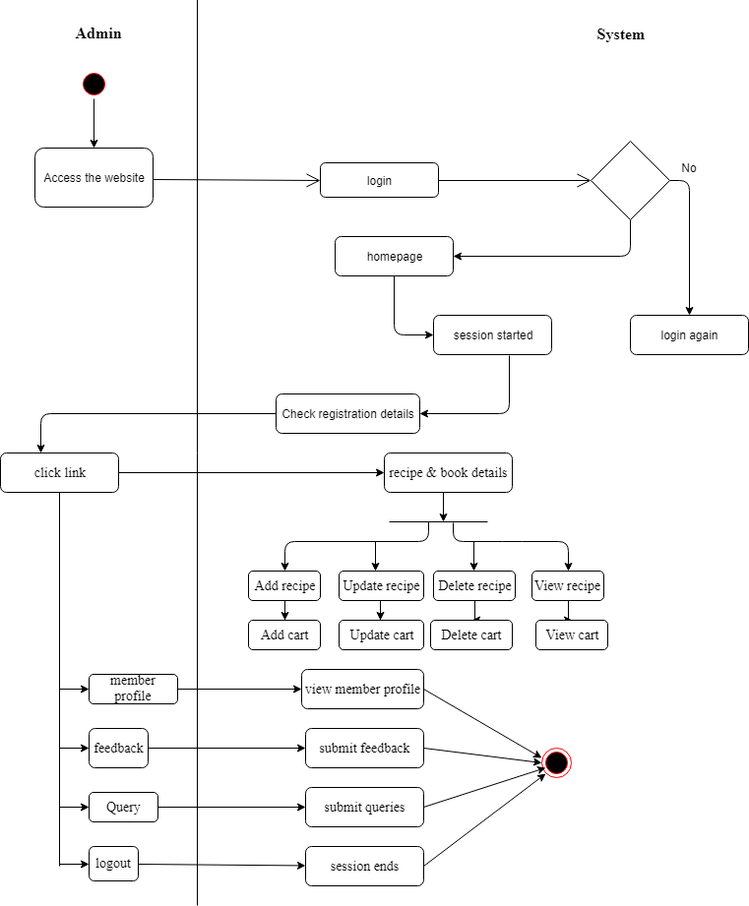

**Class Diagram**

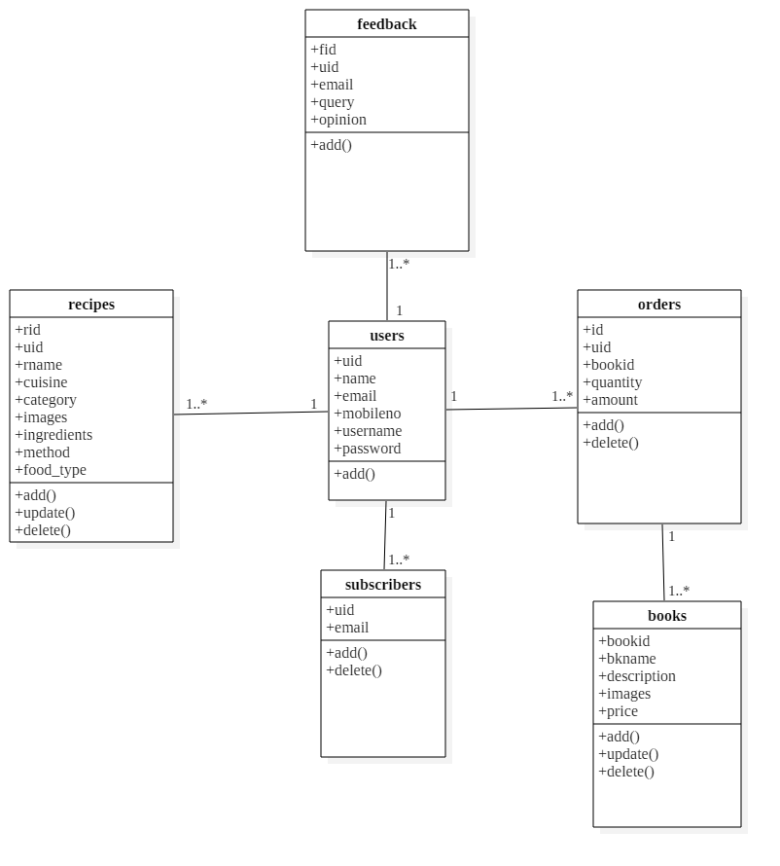

**Object Diagram**

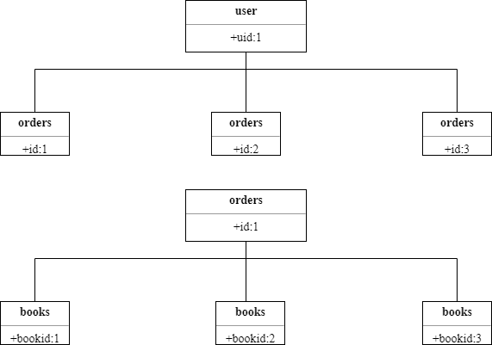

**Sequence Diagram**

**Member**

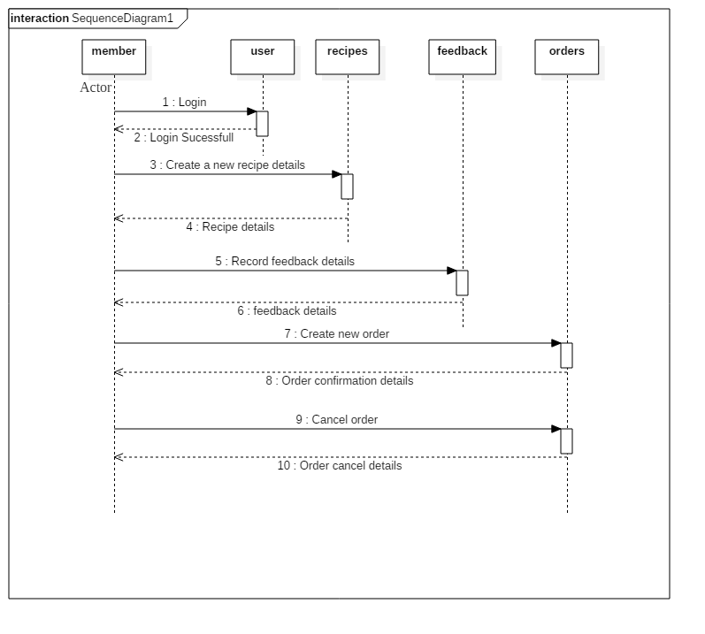

**Admin**

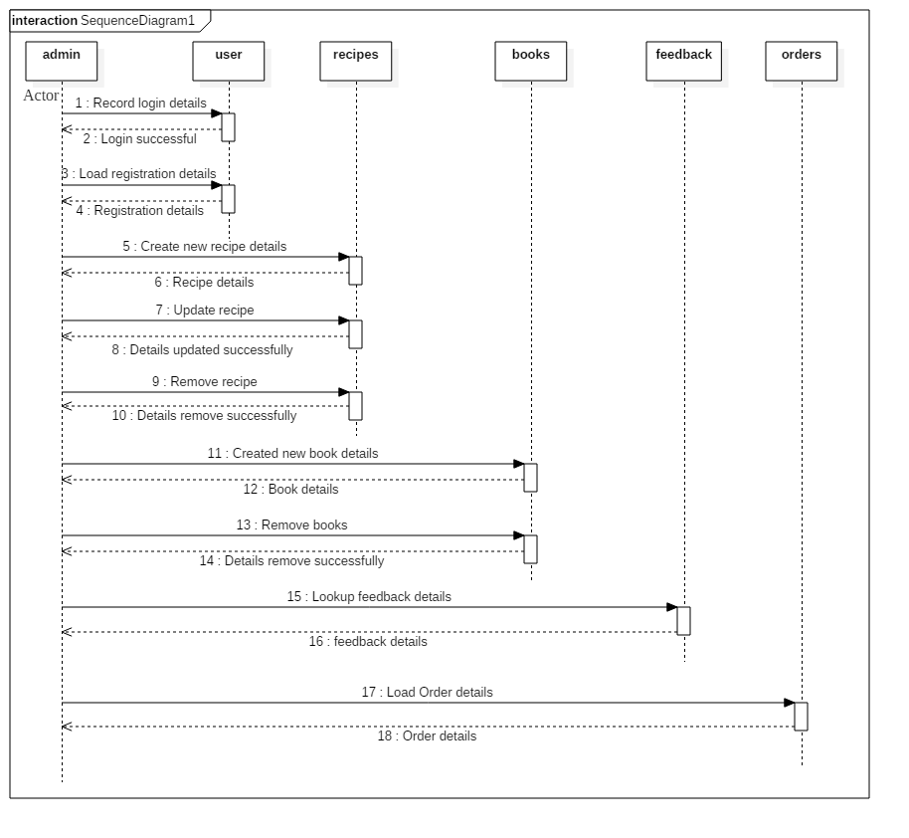

**State Diagram**

**Visitor**

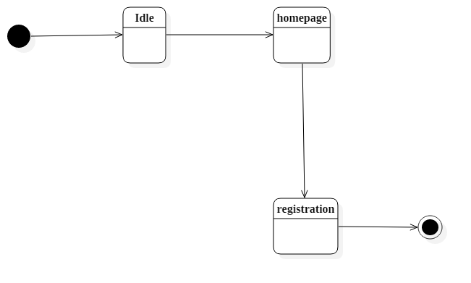

**Member:** 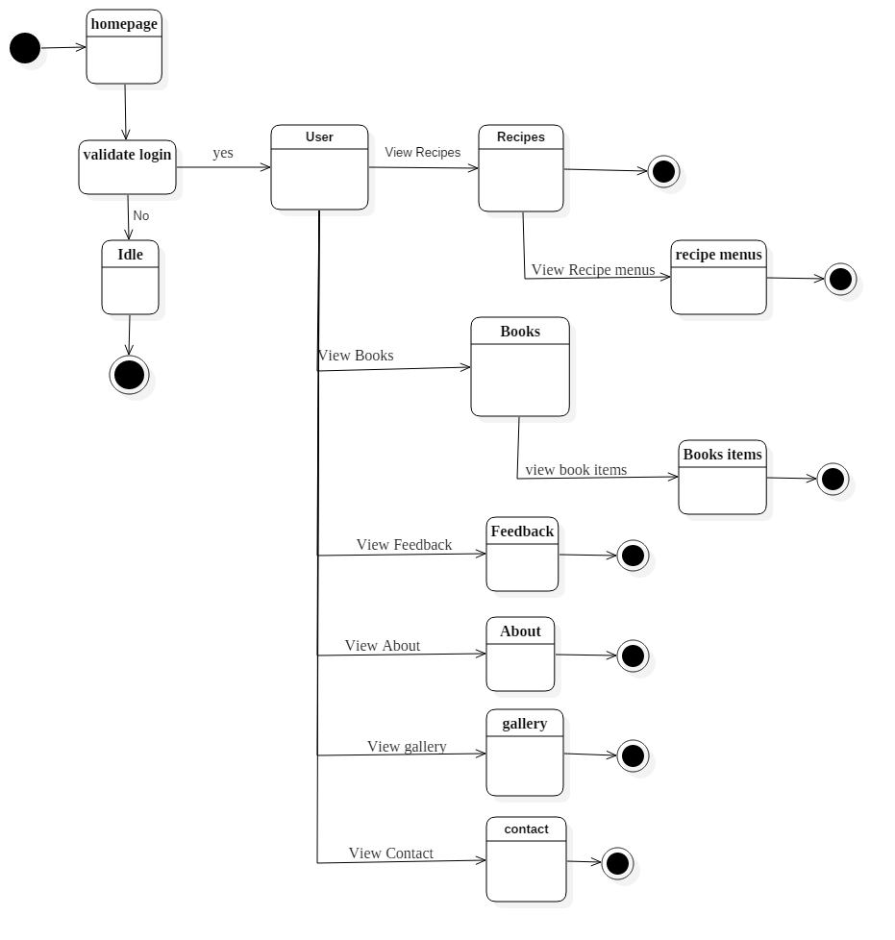

**Admin**

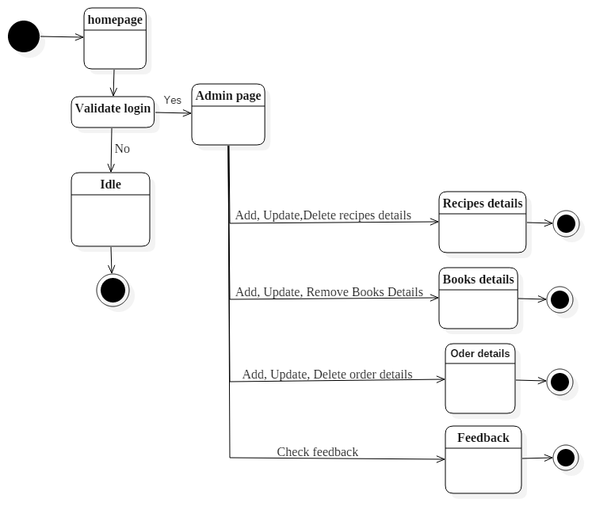

**SYSTEM** **DESIGN**

**Converting ERD to Tables**

**user**

|  |  |
| --- | --- |
| **Column Name** | **Data type** |
| Uid | Int(11) |
| Name | Varhchar(32) |
| Email | Varchar(32) |
| Mobileno | Varchar(15) |
| Username | Varchar(32) |
| Password | Varchar(32) |

**feedback**

|  |  |
| --- | --- |
| **Column Name** | **Data type** |
| Id | Int(11) |
| Uid | Int(11) |
| Email | Varchar(100) |
| Query | Varchar(1500) |
| Message | Varchar(2000) |

**Books**

|  |  |
| --- | --- |
| **Column Name** | **Data type** |
| Bookid | Int(11) |
| Bkname | Varhchar(50) |
| Description | Varchar(1000) |
| Images | longblob |
| Price | Int(10) |

**Orders**

|  |  |
| --- | --- |
| **Column Name** | **Data type** |
| Id | Int(11) |
| Uid | Int(11) |
| Bookid | Int(11) |
| Quantity | Int(10) |
| Amount | Decimal(6,0) |

**Subscribers**

|  |  |
| --- | --- |
| **Column Name** | **Data type** |
| Id | Int(11) |
| Email | Varchar(32) |

**Slideimg**

|  |  |
| --- | --- |
| **Column Name** | **Data type** |
| Id | Int(11) |
| Name | Varchar(50) |
| Images | longblob |

**Design Class Diagram**

**Visitor**

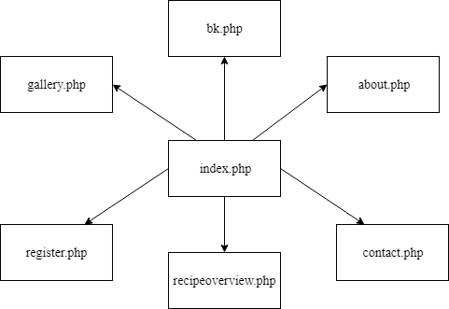

-

**Member**

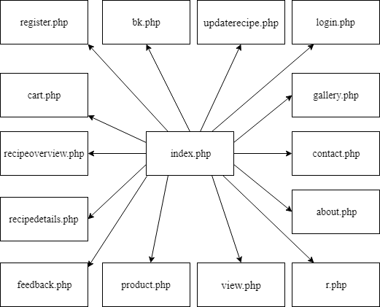

**Admin**

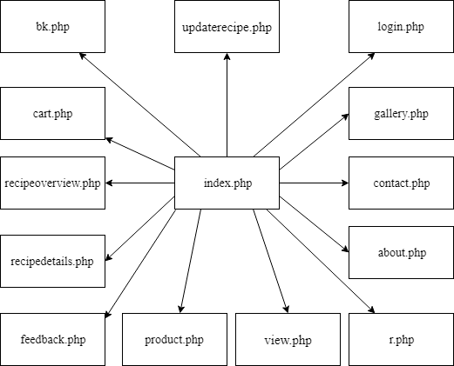

**Component Diagram**

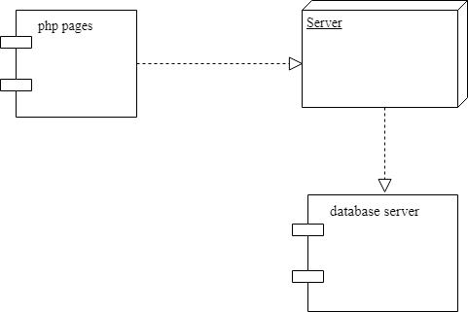

**Package Diagram**

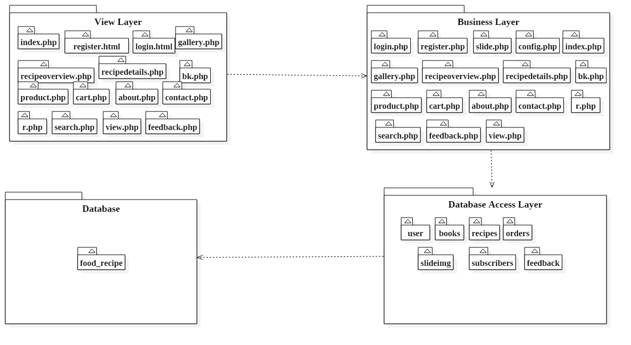

**Deployment Diagram**

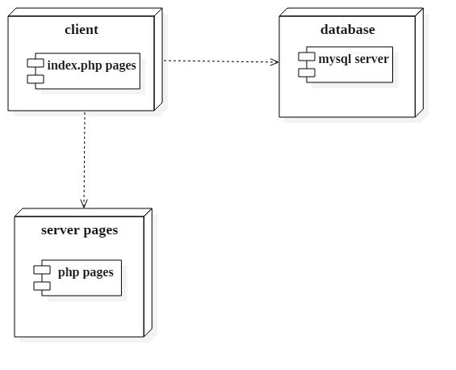

**System Coding**

**Menu Tree/ Sitemap**

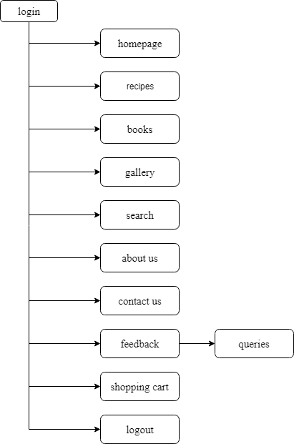

**List of Tables with attributes and constraints**

**Database: food_recipe**

**Tables**

**user**

|  |  |  |
| --- | --- | --- |
| **Column Name** | **Data type** | **Constraint** |
| uid | Int(11) | Primary key |
| name | Varhchar(32) | Not null |
| email | Varchar(32) | Not null |
| mobileno | Varchar(15) | Not null |
| username | Varchar(32) | Not null |
| password | Varchar(32) | Not null |

**contact**

|  |  |  |
| --- | --- | --- |
| **Column Name** | **Data type** | **Constraint** |
| id | Int(11) | Primary key |
| uid | Int(11) | Foreign key |
| email | Varchar(100) | Not null |
| query | Varchar(1500) | Not null |
| opinion | Varchar(2000) | Not null |

**books**

|  |  |  |
| --- | --- | --- |
| **Column Name** | **Data type** | **Constraint** |
| bookid | Int(11) | Primary key |
| bkname | Varhchar(50) | Not null |
| description | Varchar(1000) | Not null |
| images | longblob | Not null |
| price | Int(10) | Not null |

**orders**

|  |  |  |
| --- | --- | --- |
| **Column Name** | **Data type** | **Constraint** |
| id | Int(11) | Primary key |
| uid | Int(11) | Foreign key |
| bookid | Int(11) | Foreign key |
| quantity | Int(10) | Not null |
| amount | Decimal(6,0) | Not null |

**subscribers**

|  |  |  |
| --- | --- | --- |
| **Column Name** | **Data type** | **Constraint** |
| id | Int(11) | Primary key |
| email | Varchar(32) | Not null |

**slideimg**

|  |  |  |
| --- | --- | --- |
| **Column Name** | **Data type** | **Constraint** |
| id | Int(11) | Primary key |
| name | Varchar(50) | Not null |
| Images | longblob | Not null |

**Program Description with naming conventions**

|  |  |
| --- | --- |
| **Forms** | **description** |
| index.php | It contains the homepage data which displays the recipes and recipe books. |
| register.html | It contains the registration form for the registration purpose. |
| login.html | It contains the login form for the registered user for the website. |
| recipeoverview.php | It contains the recipe images and name. |
| recipedetails.php | It contains recipe details. |
| bk.php | It contains the books images and name. |
| product.php | It contains book details. |
| cart.php | It contains cart details. |
| gallery.php | It contains all recipes and books images. |
| view.php | It contains particular user’s recipe details. |
| search.php | It contains recipe and books searched details. |
| updaterecipe.php | It contains the update form for existing recipe modification. |
| r.php | It contains the new recipe upload form. |
| contact.php | It contains contact details. |
| feedback.php | It contains the feedback form. |
| about.php | It contains details about chef. |

**Validations**

For validation purpose in this Website it includes the following validations

1. During registration it check that none of the field is vacant.

2. While entering the details following are validated

• Email id.

• Password field equals with Confirm Password field.

• For phone no. only number should be entered.

3. During login it checks whether such user exists from the database who had registered for the website.

4. Empty fields not allowed each field should contain values.

5. Registered user logs out from the session.

|  |  |  |
| --- | --- | --- |
| **Rule** | **Parameter** | **Description** |
| required | No | Returns FALSE if the form element is empty. |
| valid_email | No | Returns FALSE if the form element does not contain a valid email address. |
| matches | Yes | Returns FALSE if the form element does not match the one in the parameter. |

**Test Cases, Test Data and Test Result**

|  |  |  |  |  |  |  |  |  |
| --- | --- | --- | --- | --- | --- | --- | --- | --- |
| **Test case** | **Module name** | **Form name** | **Test condition** | **Step procedure** | **Input test data** | **Expected output** | **Actual output** | **Result** |
| 01 | Login | login.php | Check login with input | 1. Enter only username | username: abc | Wrong username or password | Wrong username or password | pass |
|  | 2. Enter only password | Password: 123 | Wrong username or password | Wrong username or password | pass |
| Login button | 3. Complete valid login form | Username: abc  Password: 123 | Home page | Home page | pass |
| 02 | Registration | register.html | Checking entered data | 1. Enter some data in name, email field | Name: abc  Email abc@gmail.com | Please enter a valid name/email | Please enter a valid name/email | pass |
|  | 2. Enter some data in mobile no, user name, password  and  Confirm password field | Mobile no: 12345  Password: abc  Confirm password: abc | Please enter valid mobile no,  password | Please enter valid mobile no,  password | pass |
| Register button | 3.Complete valid registration form | All fields with valid data | Data inserted successfully | Data inserted successfully | pass |
| 03 | Recipe insert | r.php | Add recipe | 1.Enter some data recipe name, cuisine, category and image | Recipe name: xyz, cuisine: thai,  Category: veg,  Image: 1.jpg, | Please enter a valid  data | Please enter a valid data | pass |
|  | 2. enter some data ingredients, method and food type | ingred: chicken, method: pound chicken and food type: main course | Please enter a valid data | Please enter a valid data | pass |
| Submit button | Complete valid recipe form | All fields with valid data | Data inserted successfully | Data inserted successfully | pass |
| 04 | Recipe update | update recipe.php | Update button | Add recipe | Update | Update successfully | Update successfully | pass |
| 05 | Recipe delete | view.php | Delete button | Delete recipe | Delete | Delete  successfully | Delete  successfully | pass |
| 06 | Feed back | feedback.php | Submit button | Add feedback | All fields with valid data | Data inserted successfully | Data inserted successfully | pass |

**Screen Layouts and Reports Layouts**

**index.php**

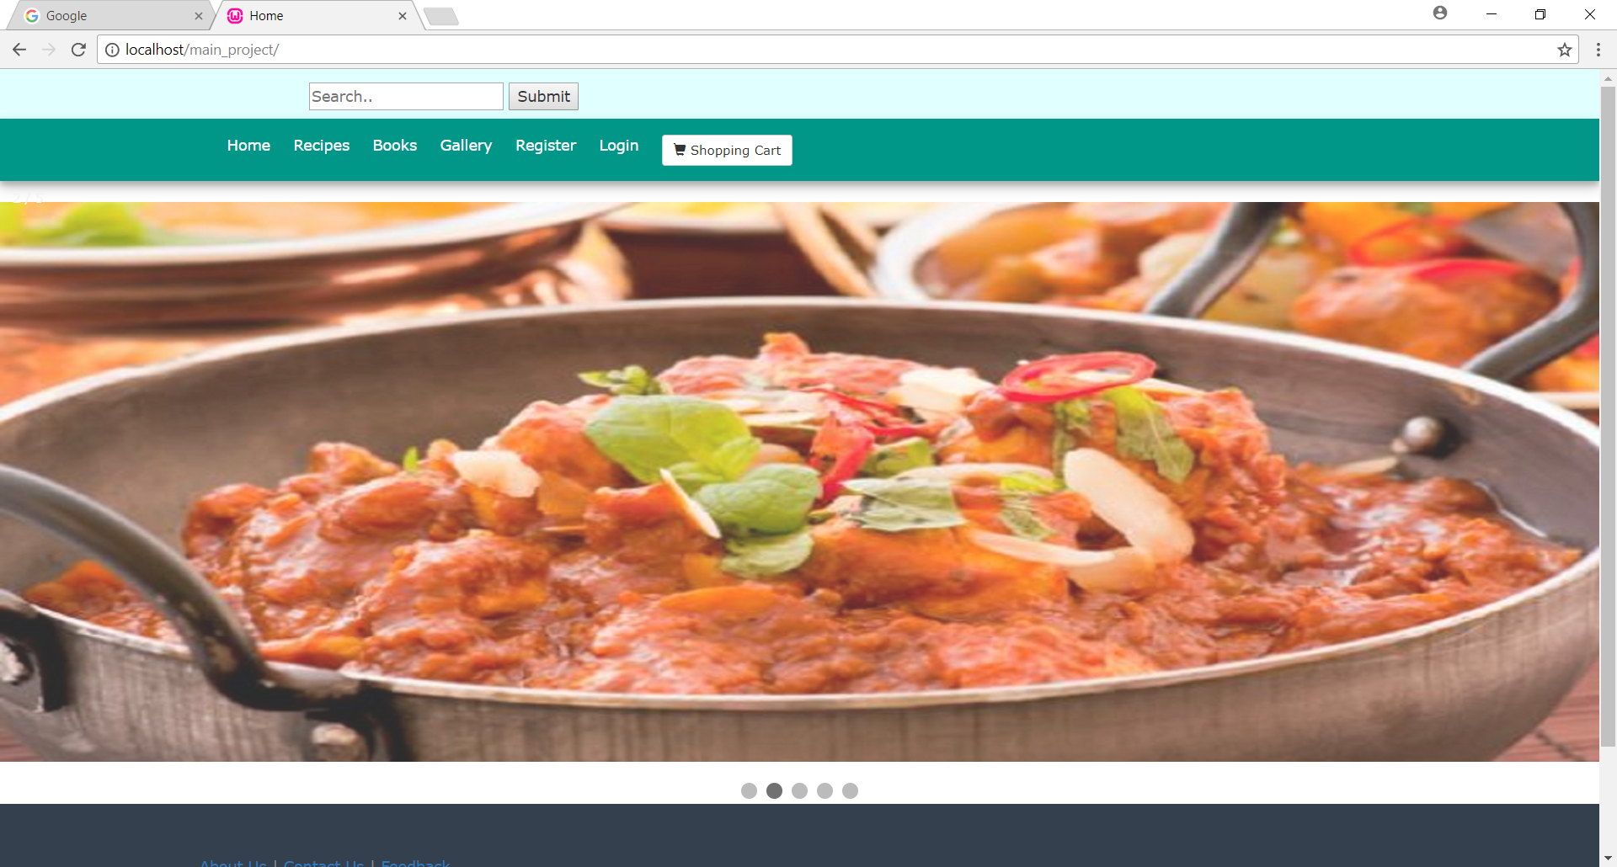

**register.html**

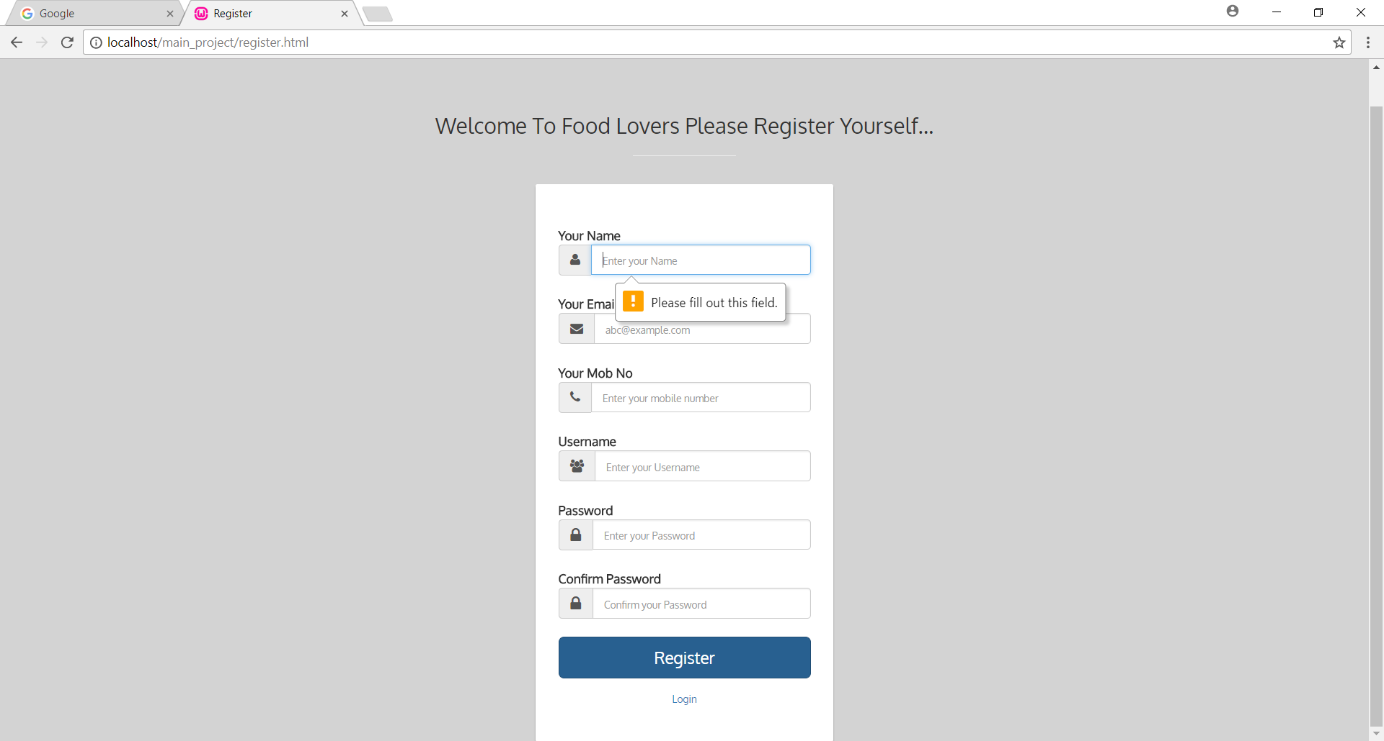

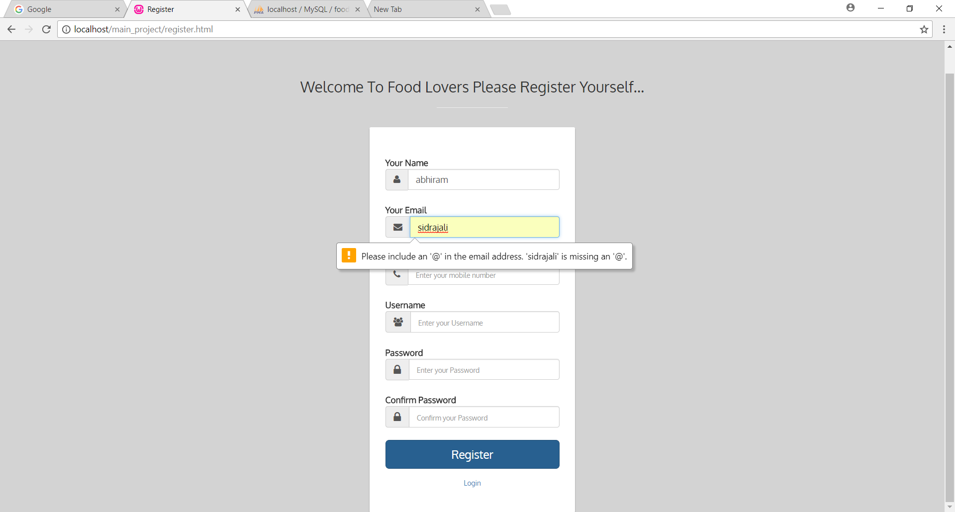

**login.html**

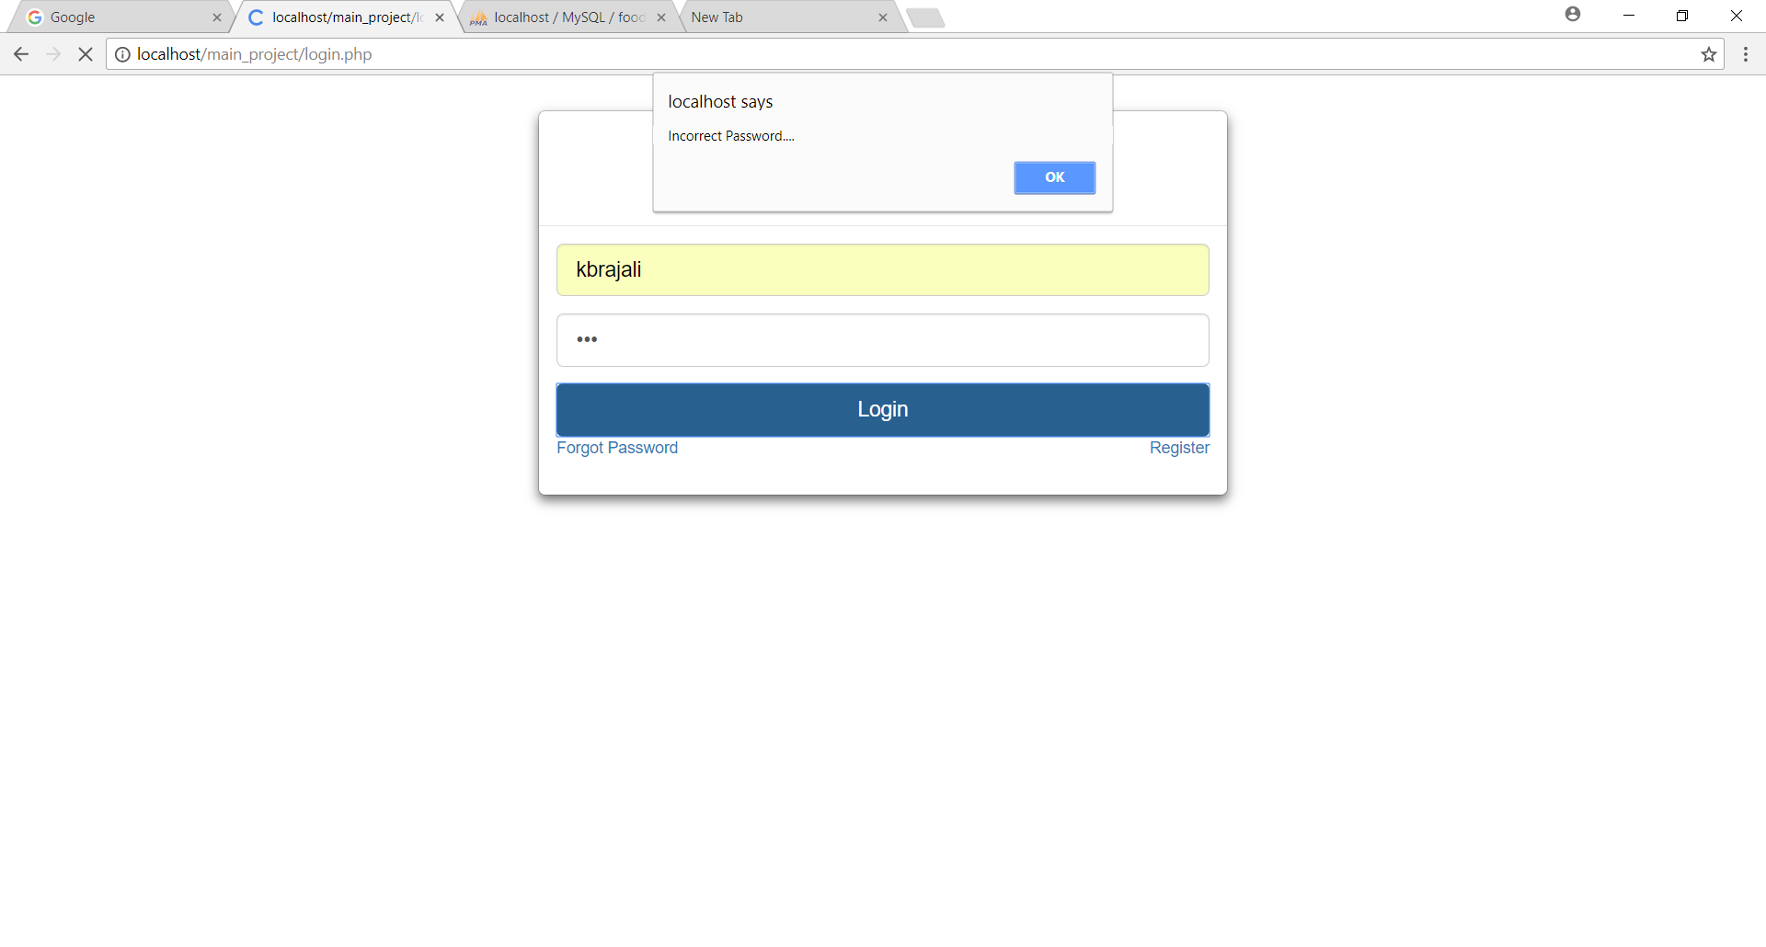

**After login**

**index.php**

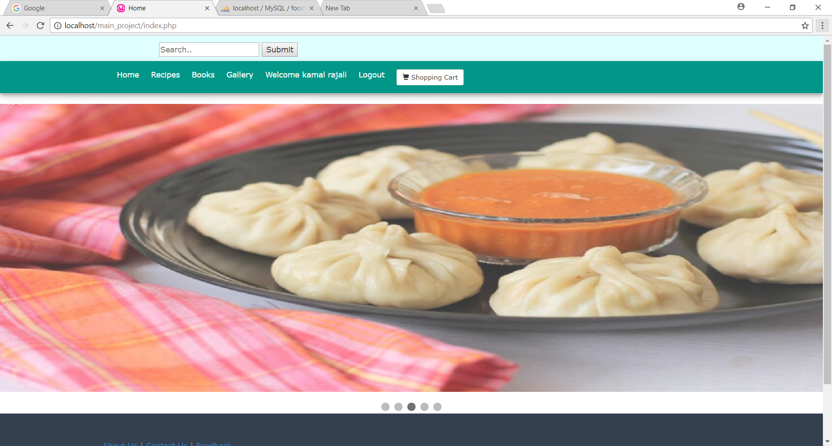

**recipeoverview.php**

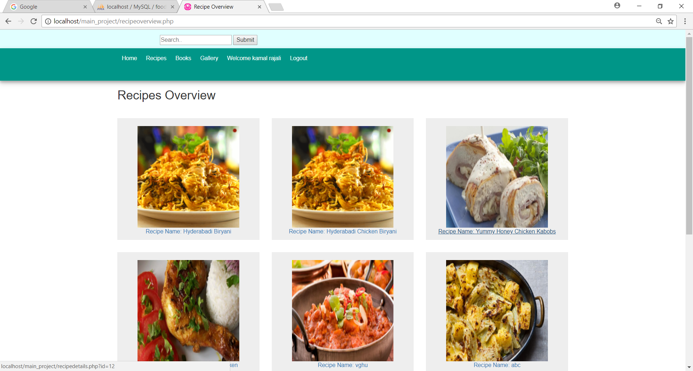

**recipedetails.php**

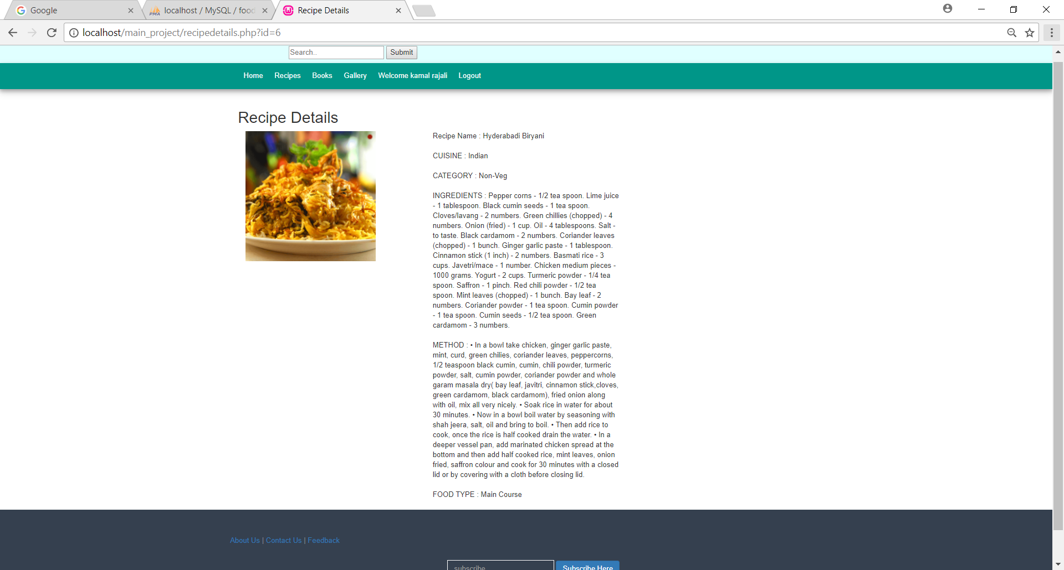

**bk.php**

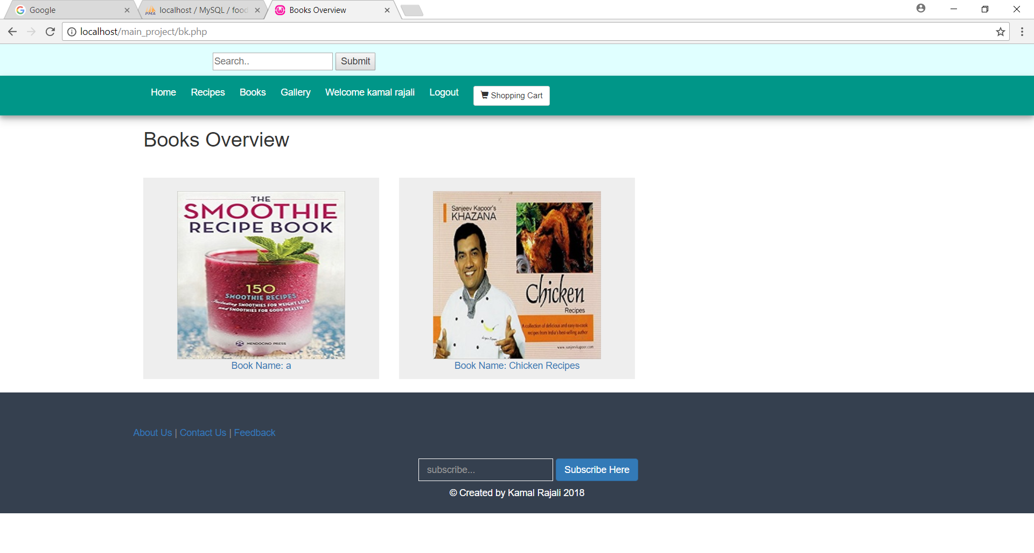

**product.php**

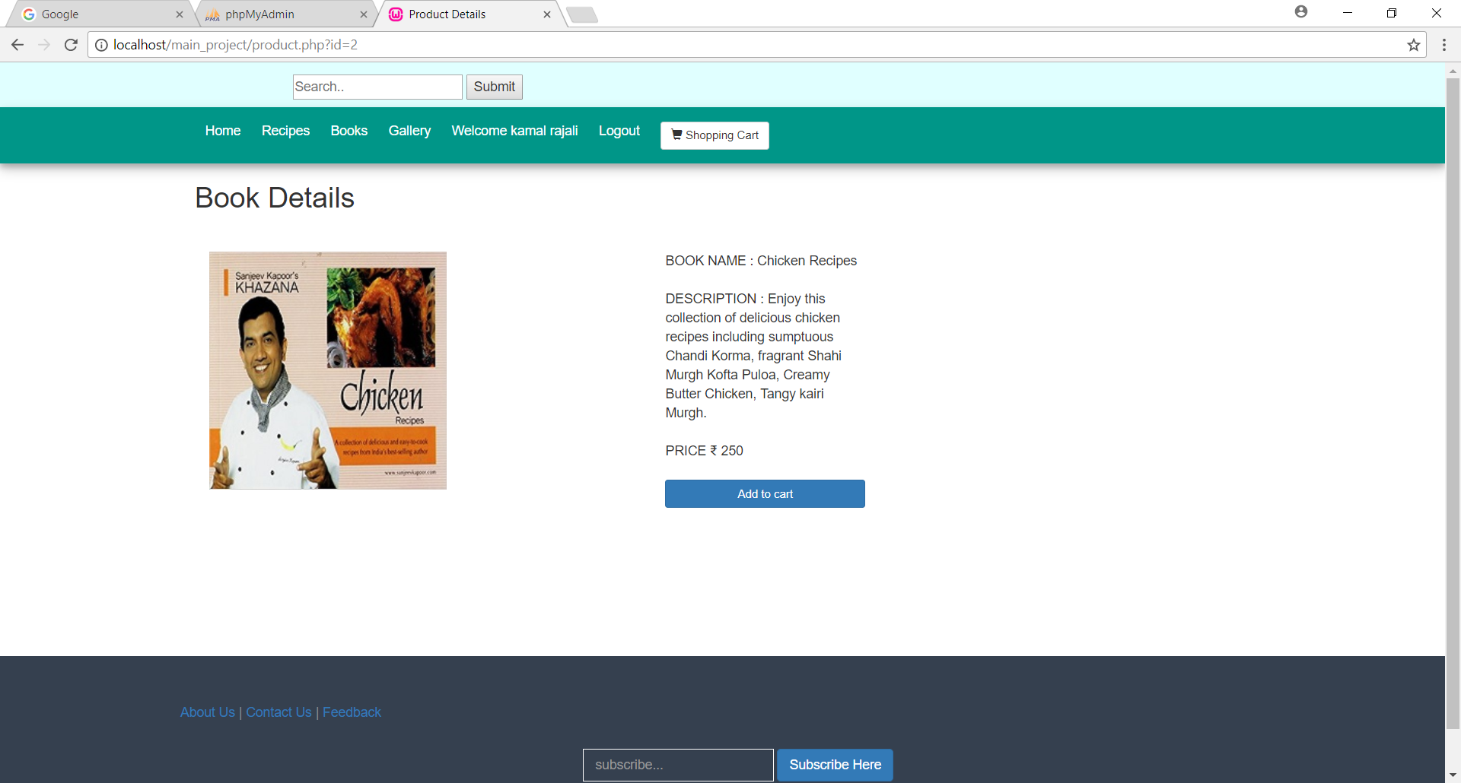

**cart.php**

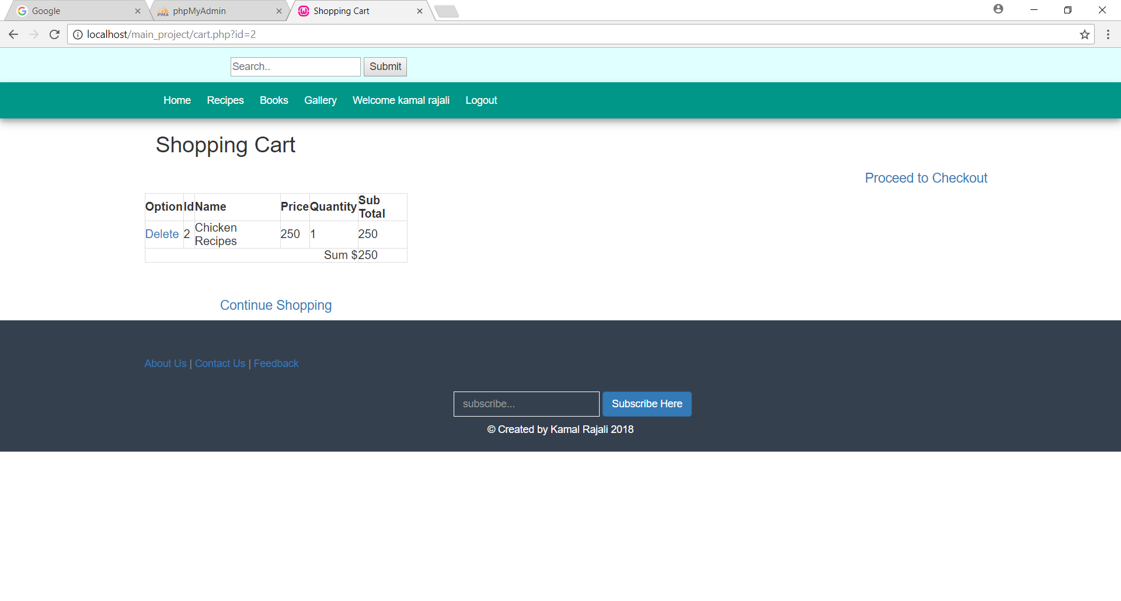

**gallery.php**

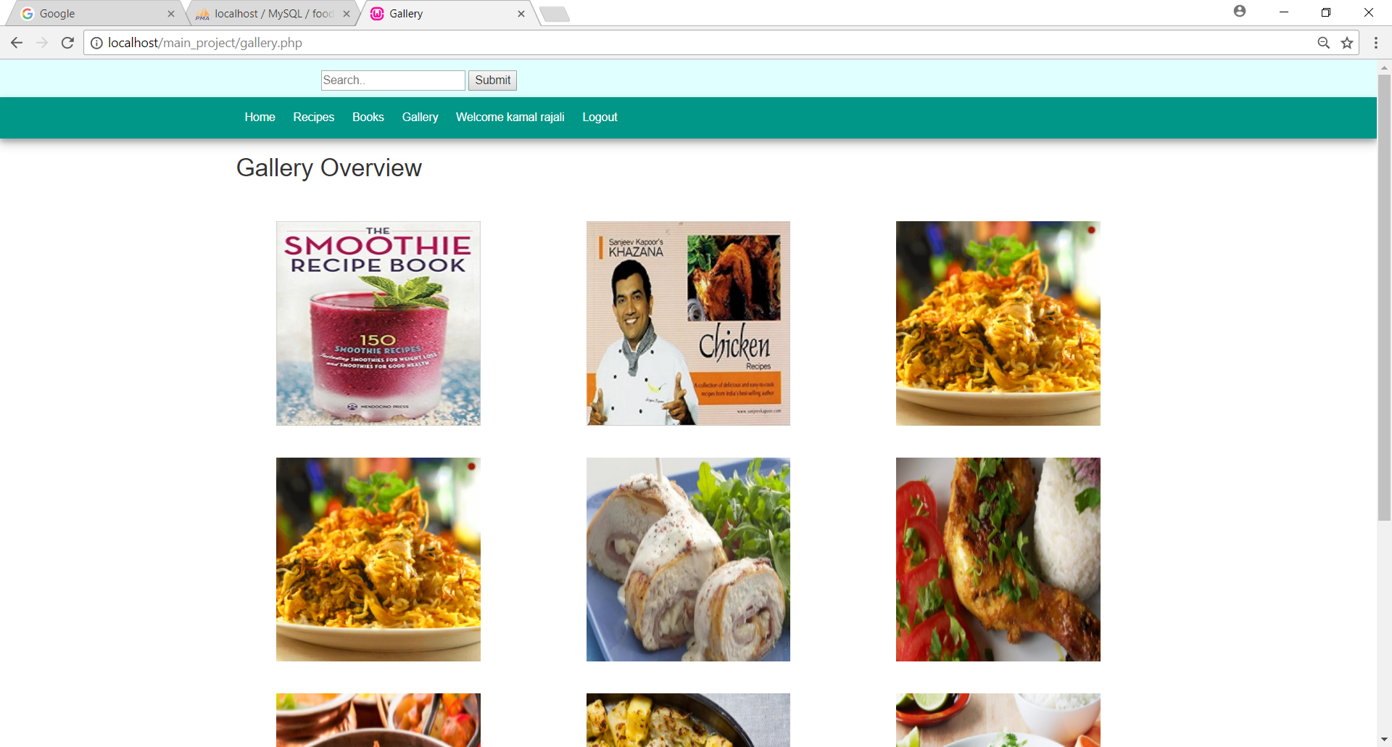

**view.php**

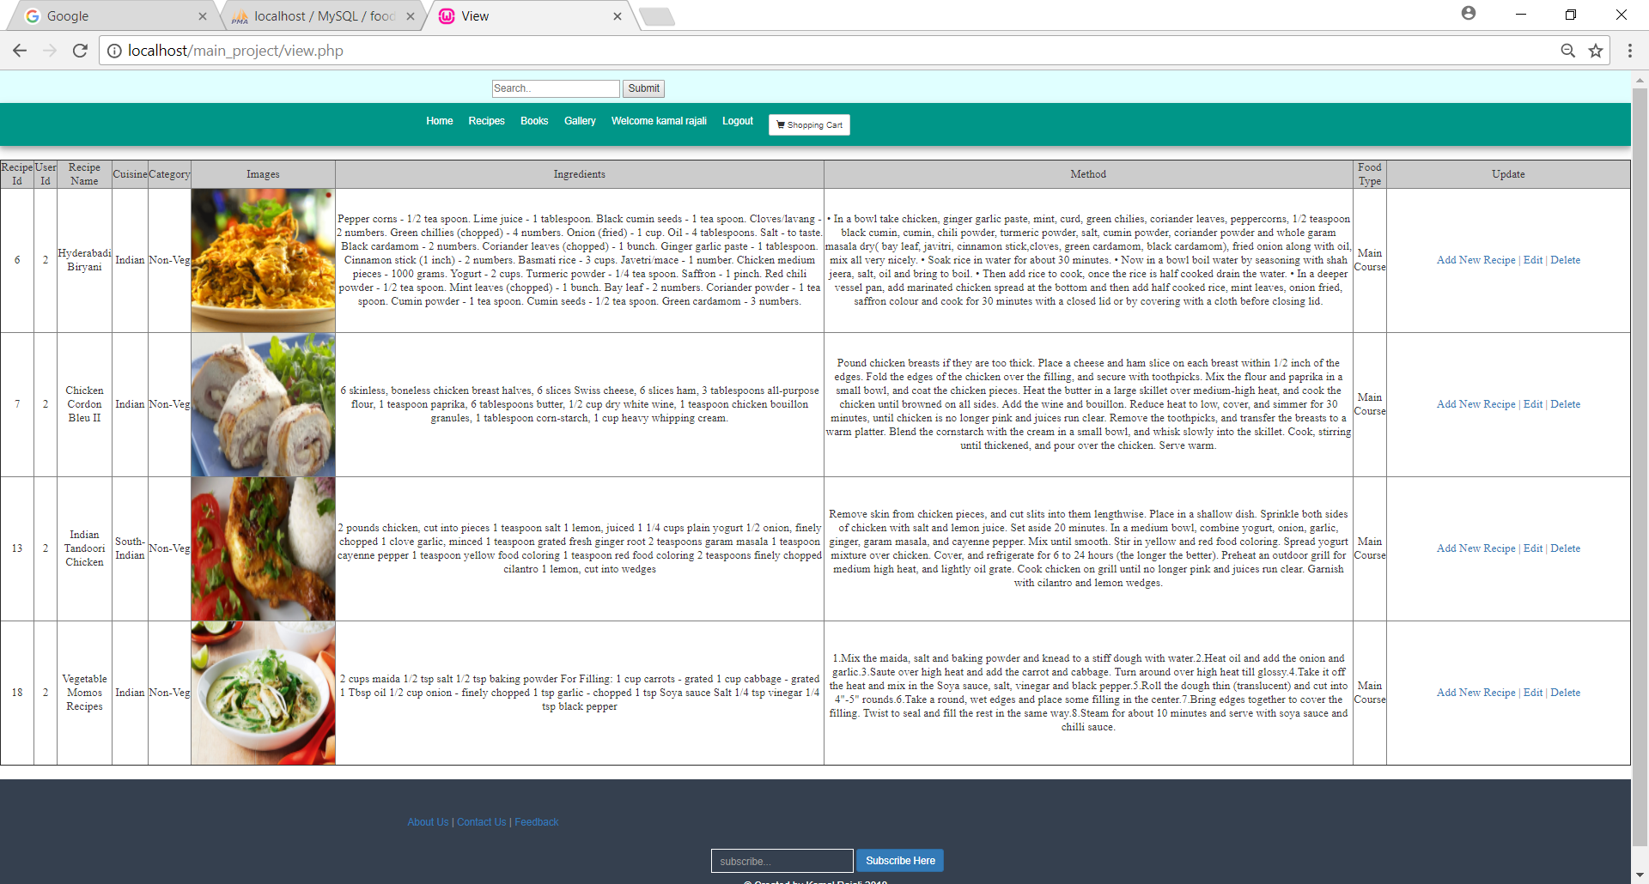

**r.php**

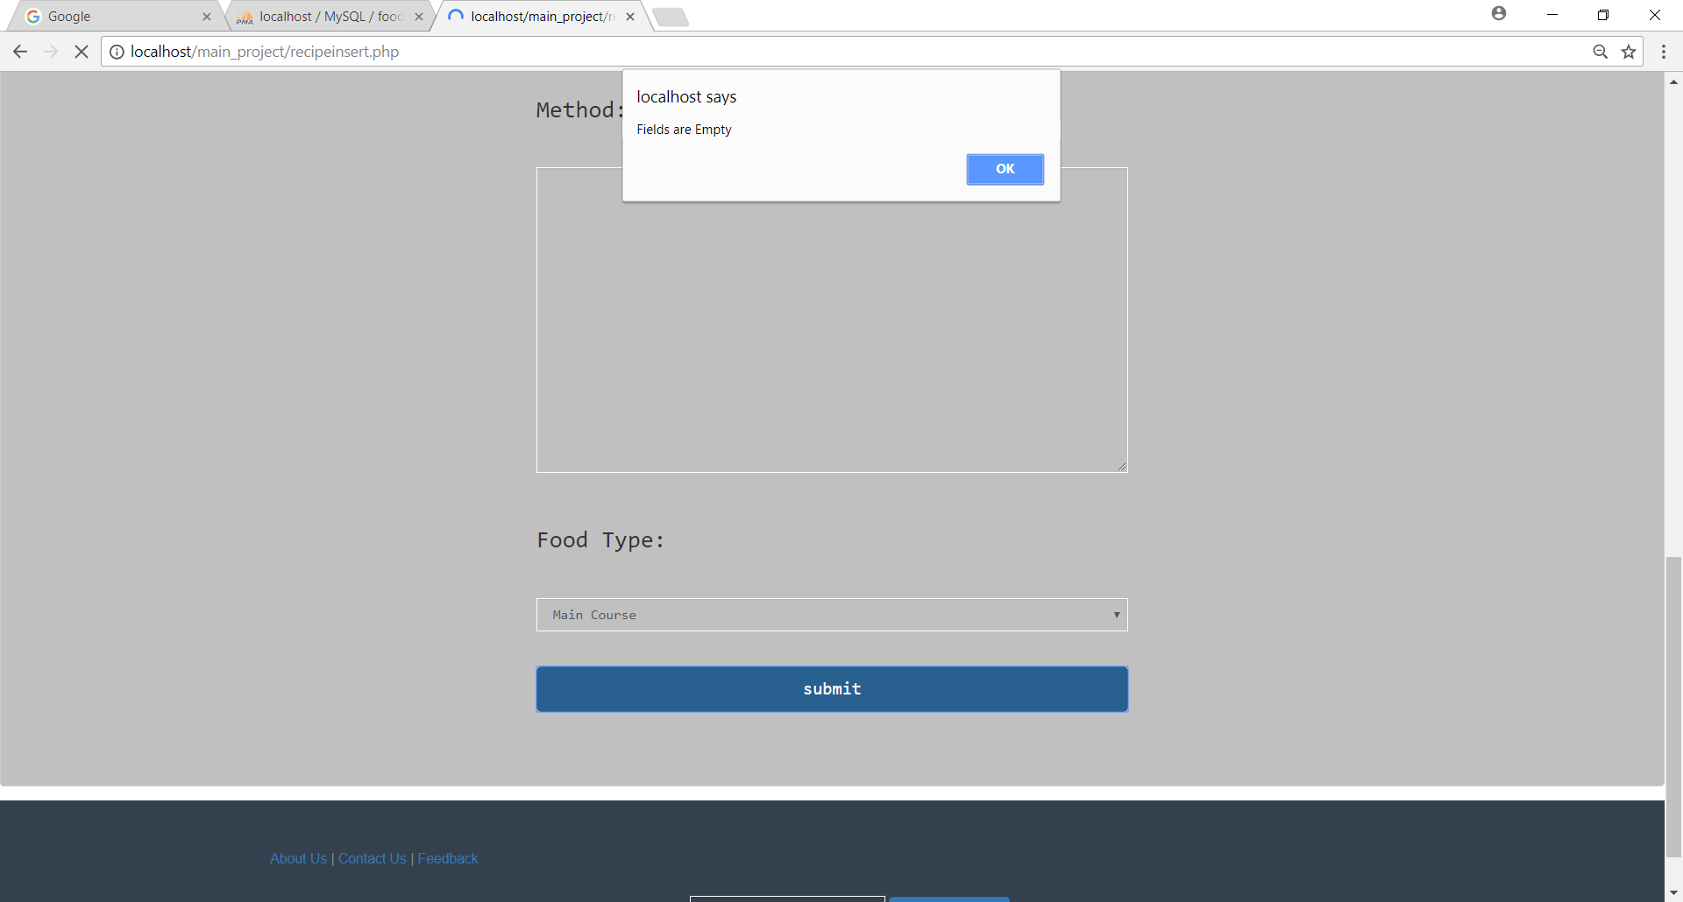

**updaterecipe.php**

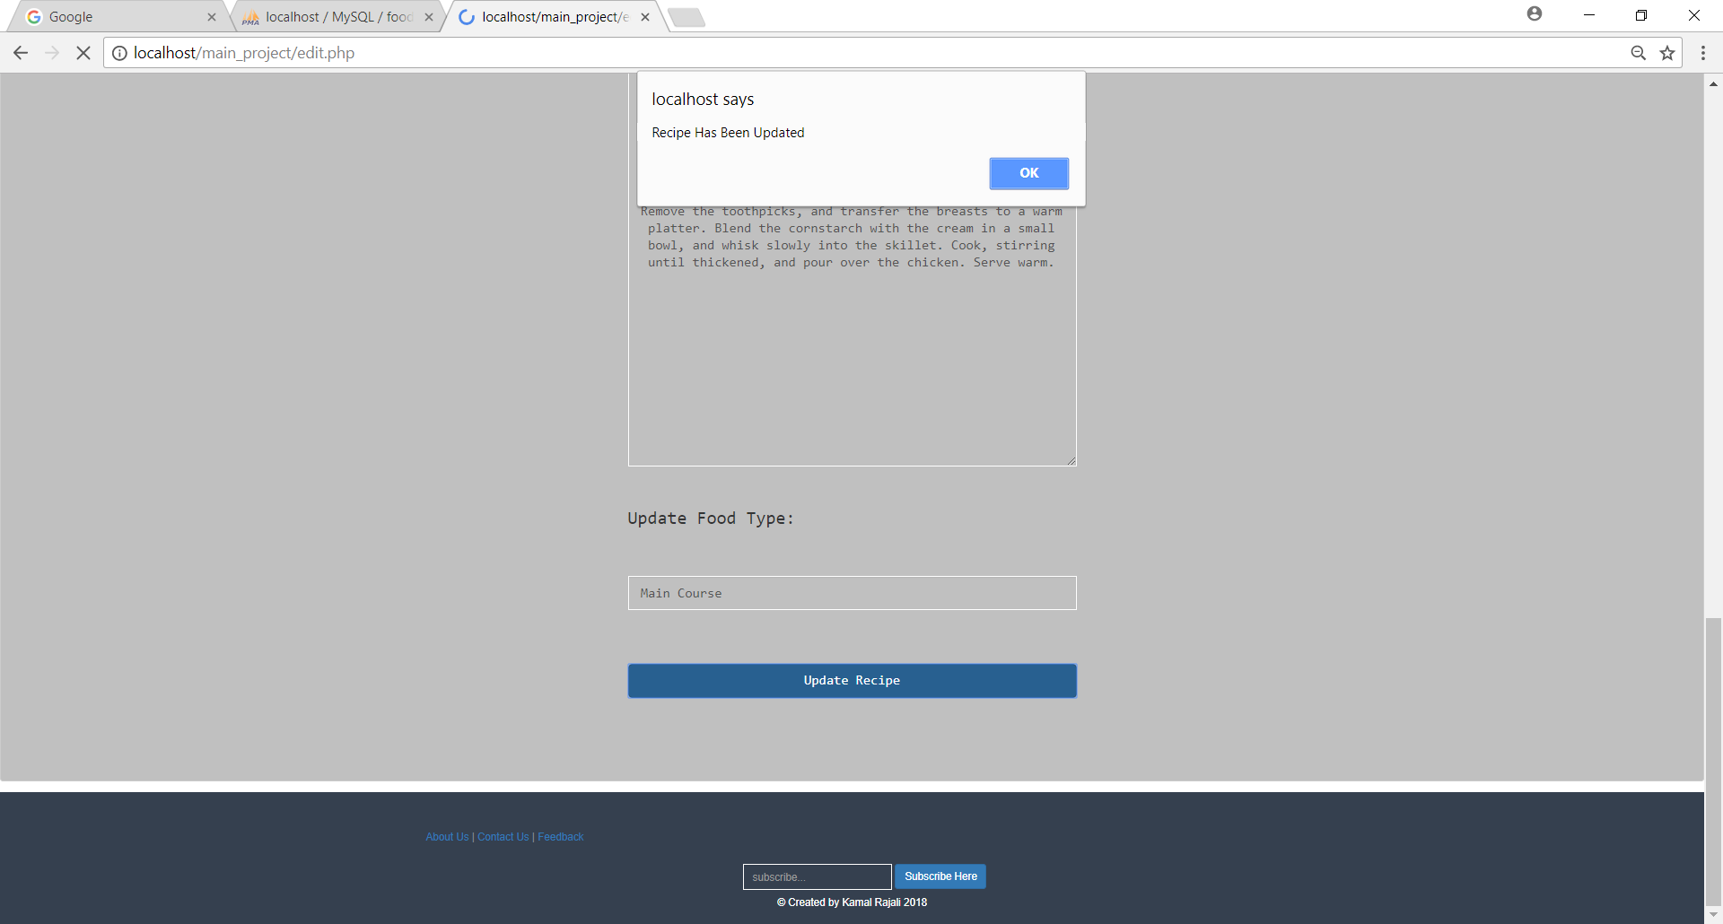

**delete.php**

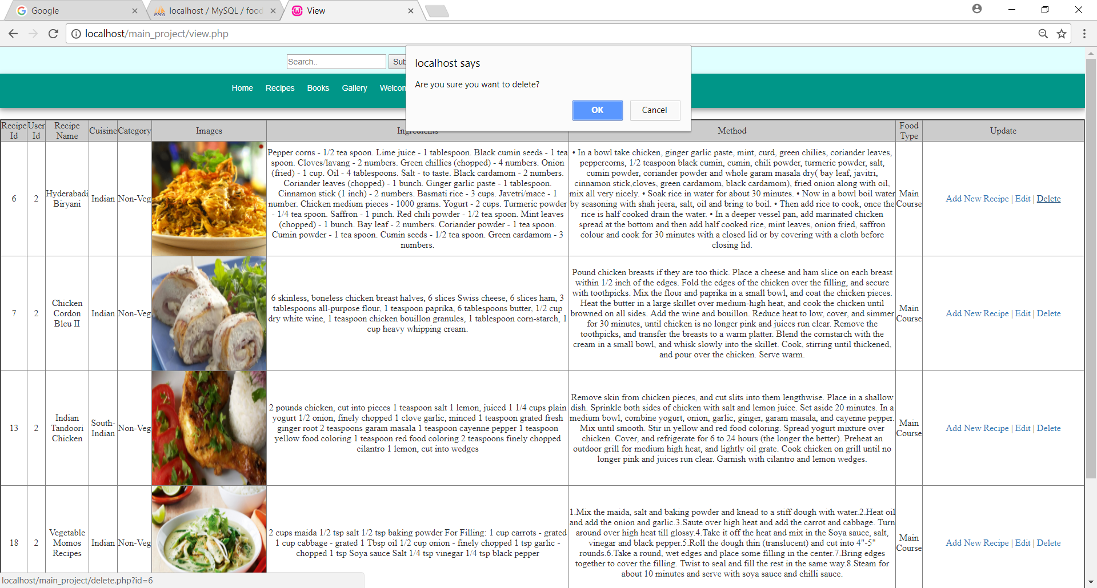

**search.php**

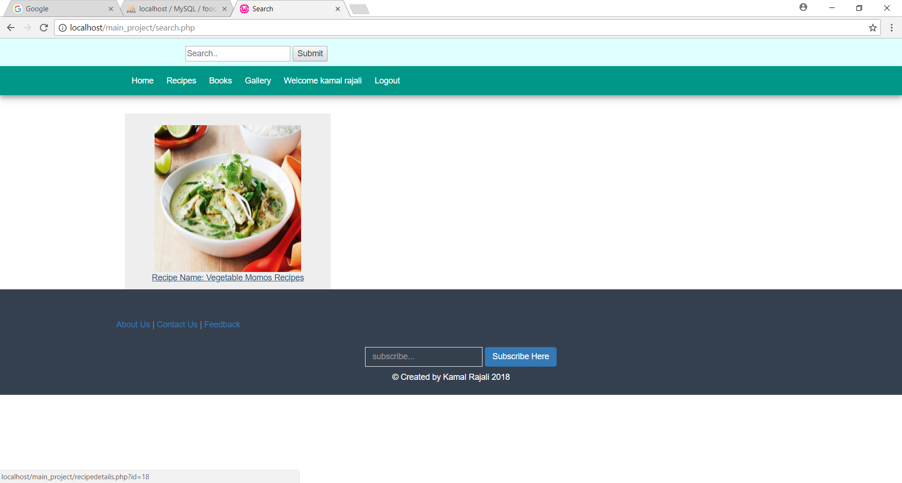

**feedback.php**

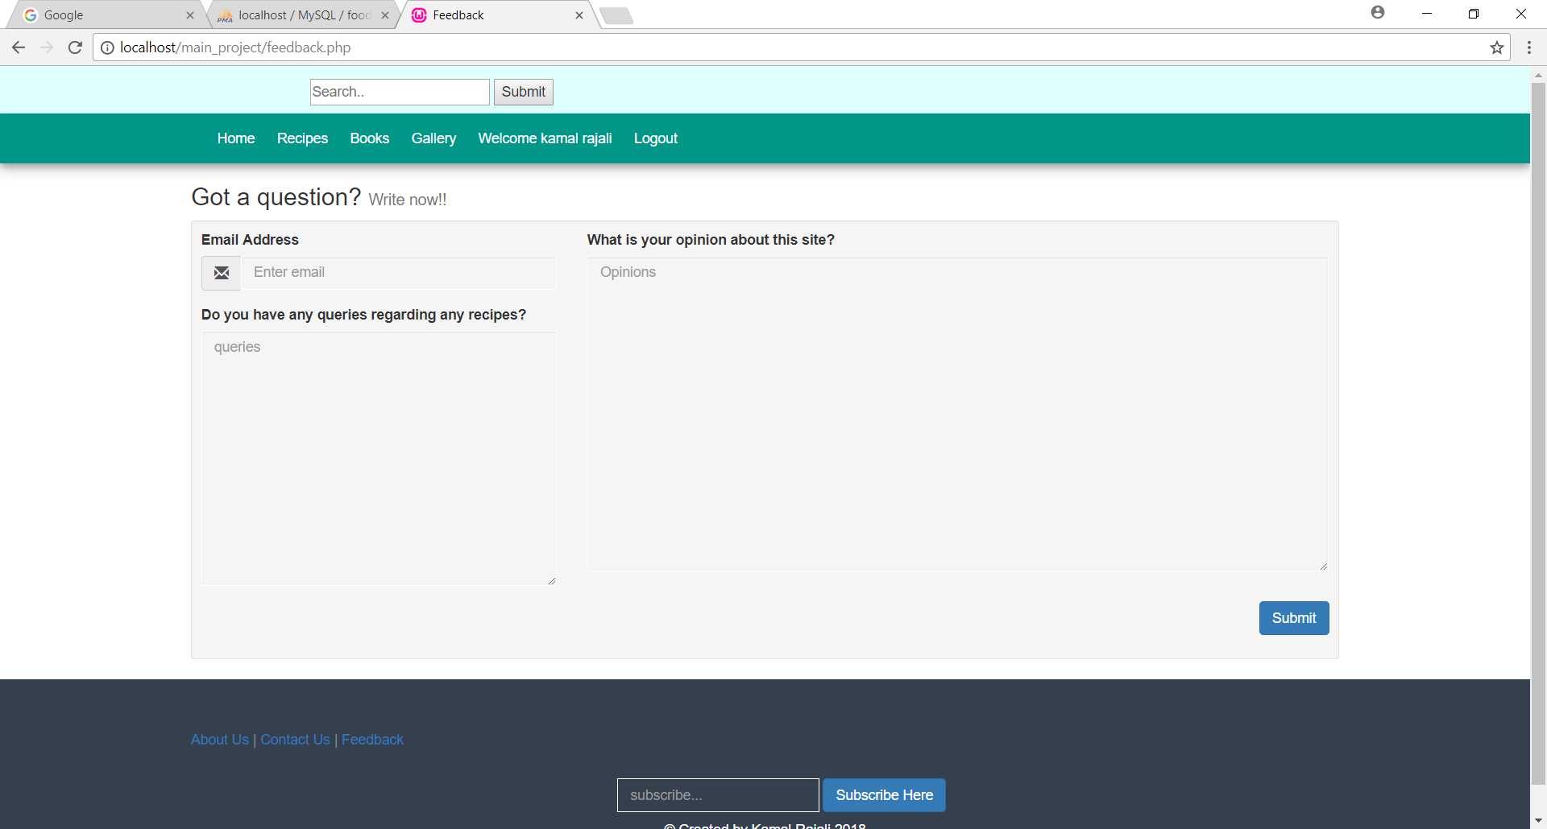

**contact.php**

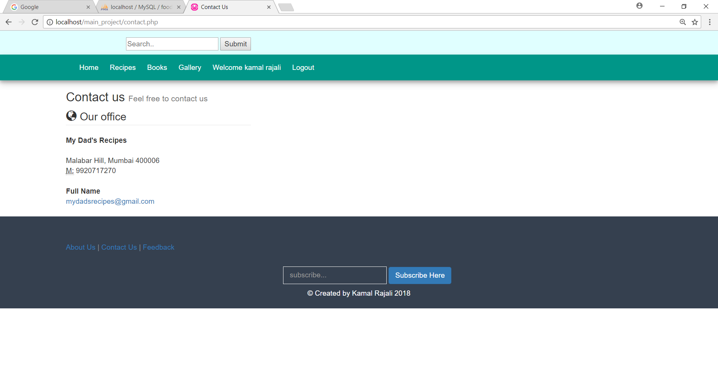

**about.php**

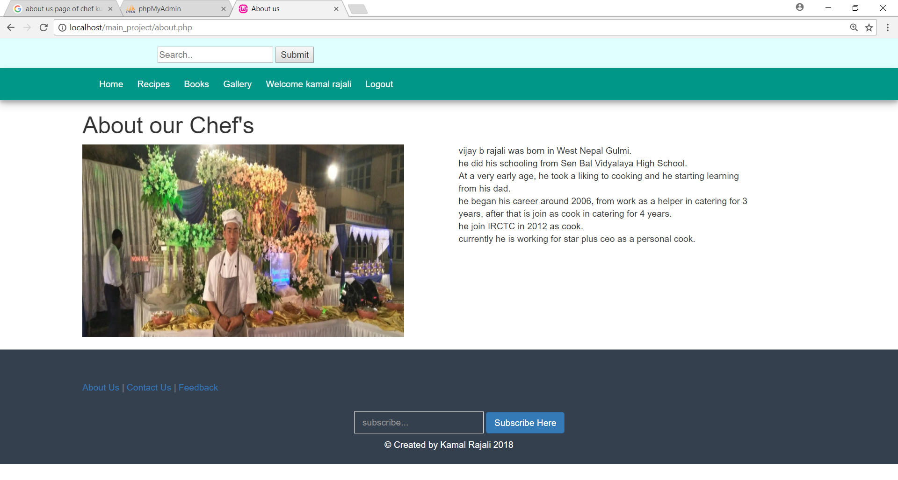

**viewrecipe.php**

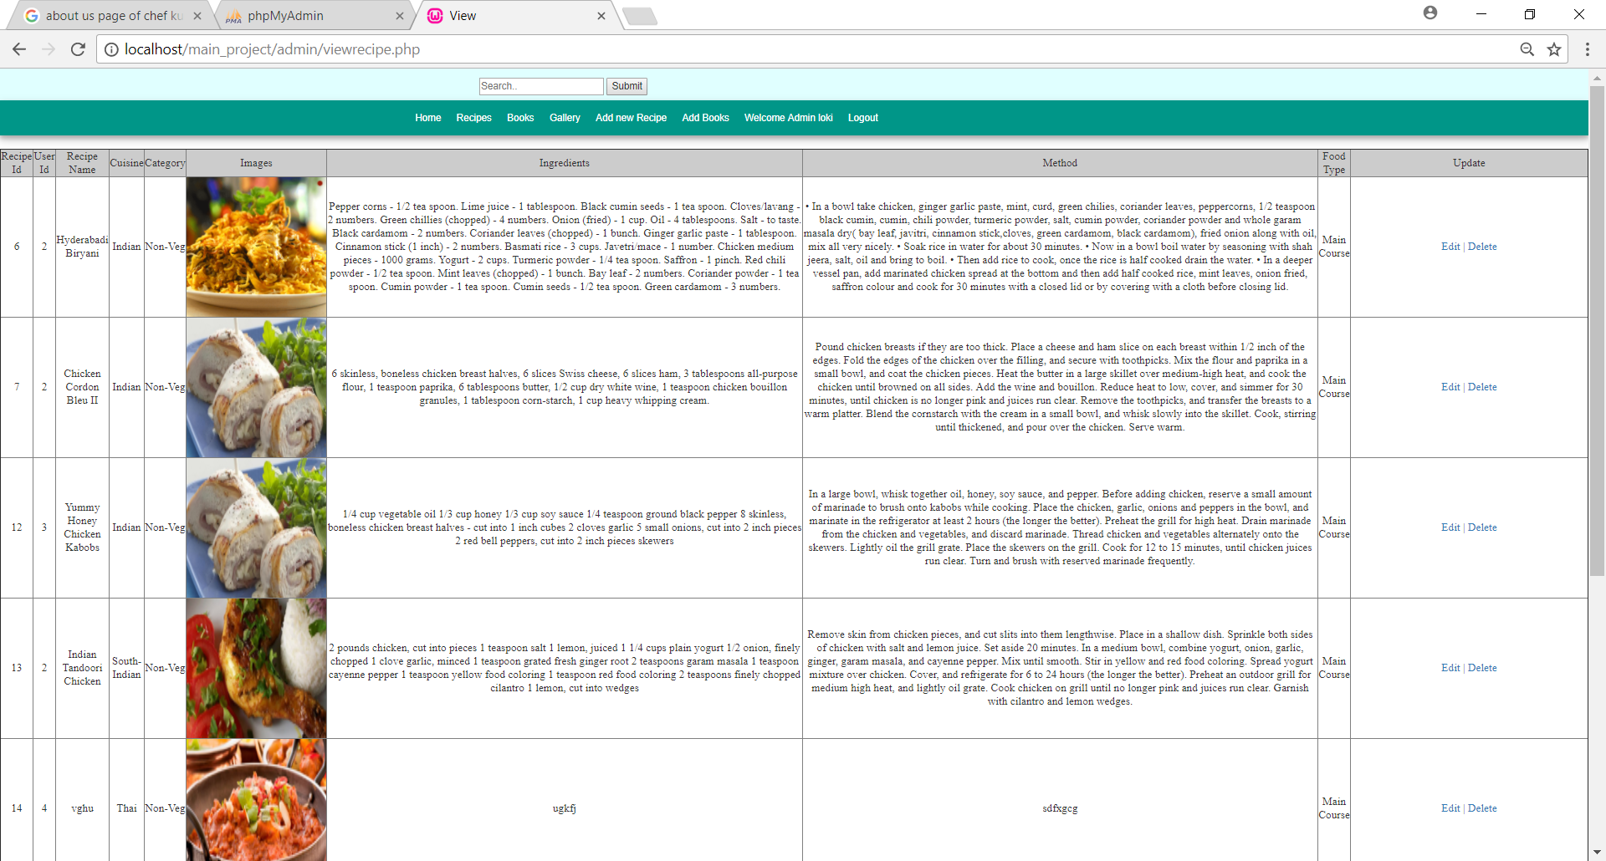

**viewbook.php**

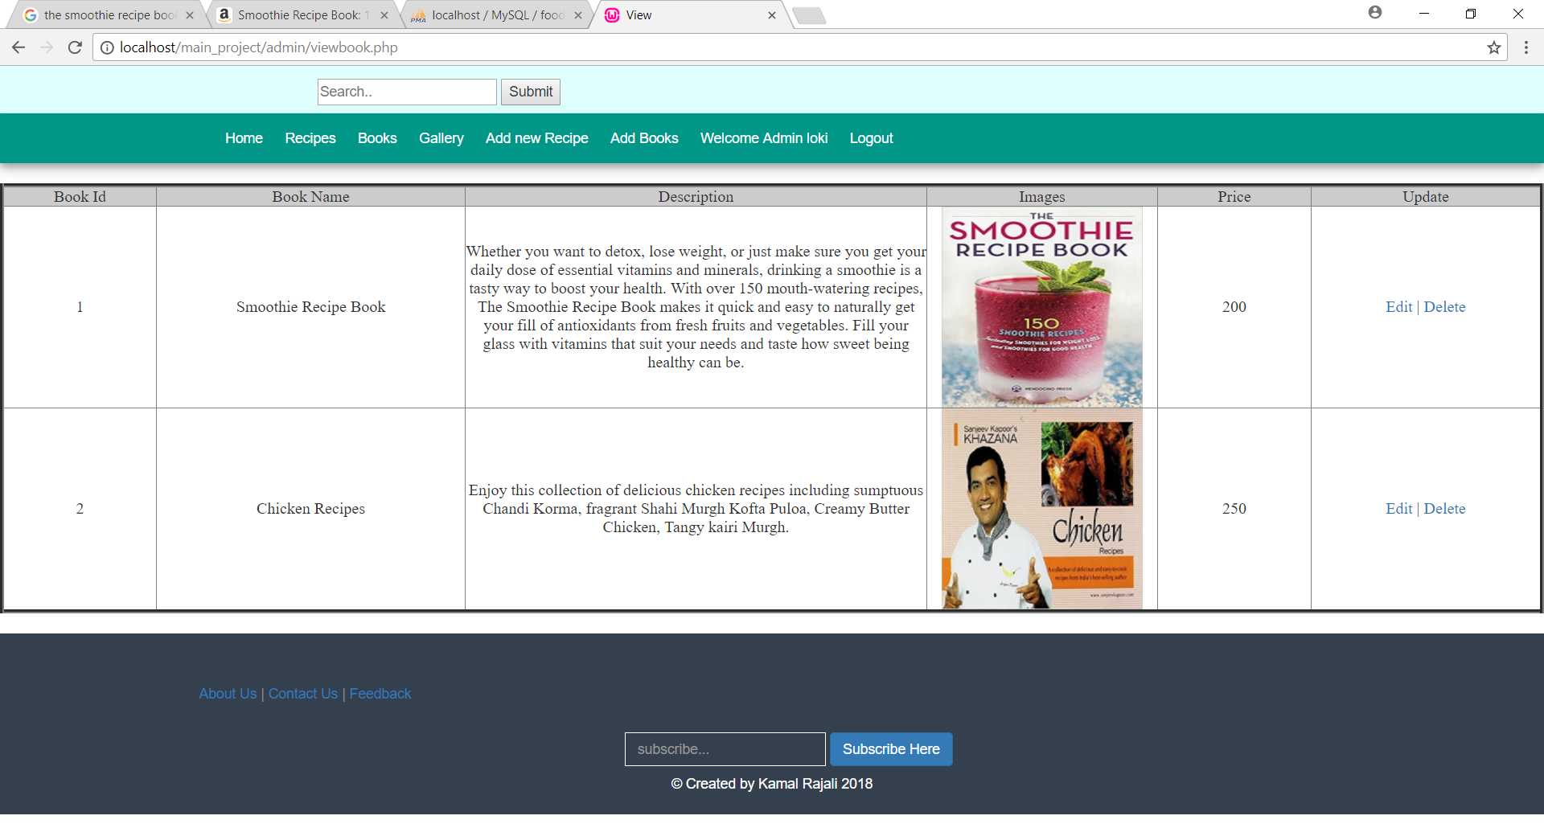

**addbook.php**

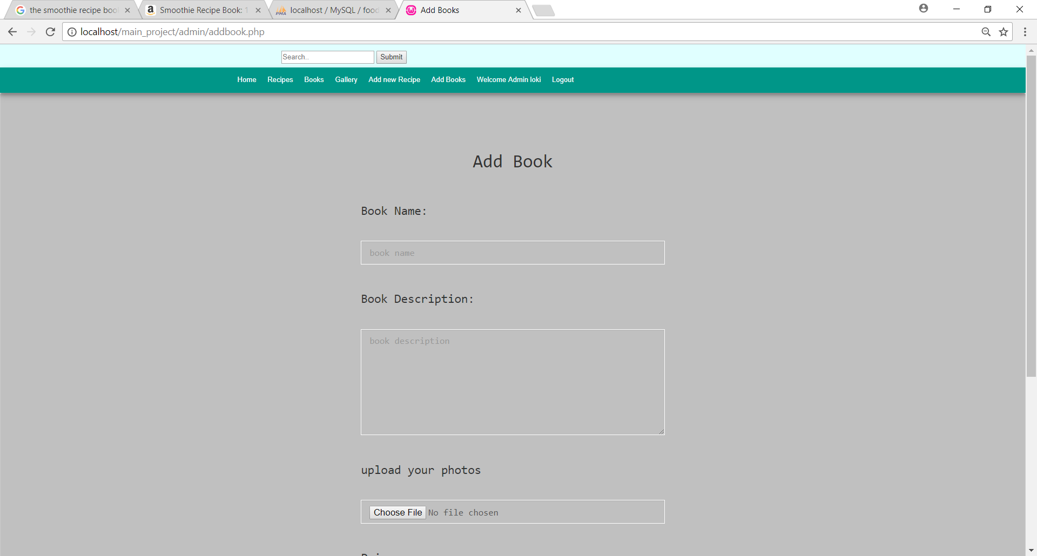

**r.php**

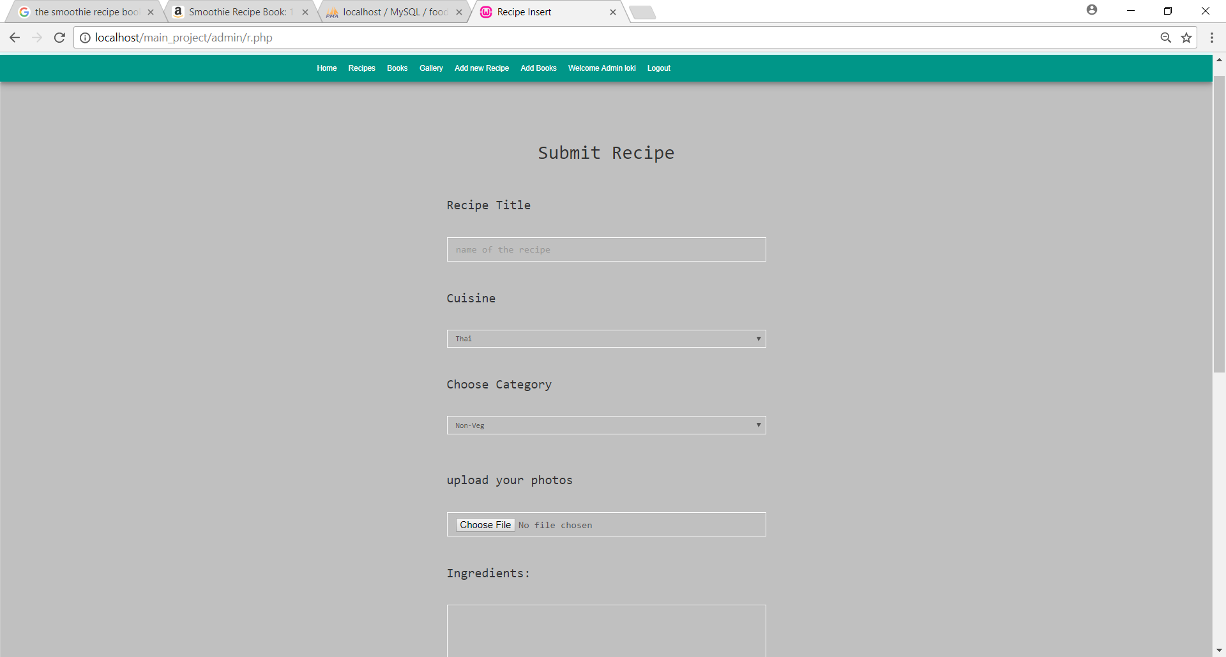

**Program Listing**

|  |
| --- |
| **Pages** |
| index.php |
| register.html |
| login.html |
| recipeoverview.php |
| recipedetails.php |
| bk.php |
| product.php |
| cart.php |
| gallery.php |
| view.php |
| search.php |
| updaterecipe.php |
| r.php |
| contact.php |
| feedback.php |
| about.php |

**Implementation and Uploading**

Any website consists of mostly web page files and images. The process used to upload the files from a desktop PC to a web server space is called FTP (file transfer protocol).

Essentially this is the opposite process from downloading files from the internet. The download process is all handled automatically by the web browsing software.

Before uploading anything one must find way to the hosting space. After signing up with the hosting company they provide information on how to upload web pages. The company provides with the details for the location of our space, a user ID and a password. To actually upload the files one need to have an **FTP*client*. This is a software application designed to facilitate the *FTP* process.

Within the FTP client one can set up the connection with the required information (the user ID and login from the hosting company). When this is set up for the site is done then drag and drop the files between folders on your PC using IE. The FTP client saves the details making it easier to do this on subsequent occasions.

1. Decide where you are going to put your pages.
2. Input the details of your account: username,password, hostname and URL.
3. Connect to the internet.
4. Open up as FTP program (like fetch-mac or ws-ftp-pc)
5. Put in the hostname of your website.
6. Put in your username
7. Put in your password
8. Connect to the site.
9. Highlights the files you would like on your website.
10. Click on the operation to transfer them to your website.

**Future Enhancements**

* In future I would like to make an android application for the website and have more relevant data for the same.
* I would like to improve website further for making online purchase of recipe and books.

**Reference and Bibliography**

* www.Getbootstrap.com
* www.W3schools.com
* [www.php.net](http://www.php.net)
* [www.wampserver.com](http://www.wampserver.com)
* www.razorpay.com
* www.https://www.tutorialspoint.com/php